**Philippine Copyright 2024**

by the Authors’ Names

and the

Polytechnic University of the Philippines

All rights reserved. Portions of this manuscript may be reproduced with proper referencing and due acknowledgment of the author.

**VILLA SALUD CATERING BOOKING AND RESERVATION SYSTEM**

A Capstone Project

Presented to the Faculty of the College of Computer and Information Sciences

Polytechnic University of the Philippines

Sta. Mesa, Manila

In Partial Fulfilment of the Requirements for the Degree

Bachelor of Science in Information Technology

.

**Armedilla, Alliyah Samantha D.**

**Gasta, Marc Oliver L.**

**Rosario, Angelica G.**

**Santos, Akisha Gelsey L.**

**January 2025**

**APPROVAL SHEET**

This capstone project **TITLE OF CAPSTONE PROJECT (IN ALL CAPS AND IN BOLD FACE)** prepared and submitted by NAME OF RESEARCHERS (FN MI LN; Alphabetical Order) in partial fulfilment of the requirements for the degree, BACHELOR OF SCIENCE IN INFORMATION TECHNOLOGY has been:

Recommended for Approval and Acceptance

Date:

___________________________ ________________

**Mr. John Dustin D. Santos, MIT**

Faculty in-Charge

___________________________ ________________

**Mr. John Dustin D. Santos, MIT**

Adviser (omit if same as FIC or none)

Approved by the Capstone Project Defense Panel:

___________________________ ________________

**Assoc. Prof. Name, MSIT**

Chair

___________________________ ________________

**Asst. Prof. Name, MIS**

___________________________ ________________

**Prof. Name, DIT**

Accepted for the Department of Information Technology:

___________________________ ________________

**Asst. Prof. Lydinar D. Dastas, MSCS**

Chairperson

Accepted for the College of Computer and Information Sciences:

___________________________ ________________

**Prof. Benilda Eleonor V. Comendador, DIT**

Dean

**ACKNOWLEDGMENTS**

*SAMPLE ONLY. YOU MAY CREATE YOUR OWN*

The researchers would like to express their sincerest gratitude to their advisor, _______ [Advisor Name], for their invaluable guidance and support throughout their master’s program. Their expertise and encouragement helped the researchers to complete this research and write this thesis.

They would also like to thank _______ [Name] and _______ [Name] for serving on their thesis committee and providing helpful feedback and suggestions.

**CERTIFICATION OF ORIGINALITY**

This is to certify that the research work presented in this capstone project, COMPLETE TITLE OF THE CAPSTONE PROJECT for the degree Bachelor of Science in Information Technology at the Polytechnic University of the Philippines embodies the result of original and scholarly work carried out by the undersigned. This capstone project does not contain words or ideas taken from published sources or written works that have been accepted as basis for the award of a degree from any other higher education institution, except where proper referencing and acknowledgement were made.

|  |  |
| --- | --- |
|  | (Wet Signature)  **NAME OF RESEARCHERS**  Researchers  _________________________  Date Signed (date, month, year) |

**ABSTRACT**

Title : Title of Capstone Project

Researcher : LN, FN MI

Degree : Bachelor of Science in Information Technology

Institution : Polytechnic University of the Philippines

Year : 2024

Adviser : Name of Adviser

(Note: Abstract should be double-spaced, and not more than 250 words)

Keywords : At least five (5) keywords must be given (To include “Polytechnic University of the Philippines”)

**EXECUTIVE SUMMARY**

For over two decades, Villa Salud has been a beloved venue for celebrations, hosting countless weddings, birthdays, and other joyous occasions. However, their reliance on traditional, manual methods for managing bookings and reservations had begun to hinder their growth and efficiency. Challenges like inaccurate record-keeping, misplaced information, slow response times to inquiries, and difficulties in coordinating schedules were becoming increasingly prevalent. Recognizing the need for a modern solution, Villa Salud embarked on a digital transformation journey, developing a comprehensive online booking and reservation system.

This innovative system leverages cutting-edge technology to streamline and enhance key aspects of Villa Salud's operations. By automating critical tasks, it empowers staff to work more efficiently, freeing them from time-consuming manual processes.

Enhanced Customer Experience: The system offers a user-friendly online booking portal, allowing customers to easily browse available dates, inquire about packages, and reserve their desired event slots with just a few clicks. Instant email confirmations and reminders provide peace of mind and ensure that no details are overlooked.

Streamlined Operations: The system centralizes all booking and reservation information, eliminating the risk of lost paperwork and ensuring accurate and up-to-date records. An intuitive admin dashboard provides staff with a real-time overview of bookings, inquiries, and event schedules, facilitating efficient planning and coordination.

Improved Efficiency: By automating tasks such as scheduling, payment processing, and communication, the system significantly reduces administrative overhead, enabling staff to focus on providing personalized customer service and enhancing the overall event experience.

Data-Driven Insights: The system collects valuable data on booking trends, customer preferences, and event popularity, providing valuable insights that can inform business decisions, optimize pricing strategies, and identify areas for improvement.

Increased Competitiveness: In today's fast-paced digital world, a robust online booking system is essential for attracting and retaining customers. By offering a convenient and efficient booking experience, Villa Salud can gain a competitive edge in the event venue market and attract a wider clientele.

The development of the Villa Salud Catering Booking and Reservation System was guided by the Agile methodology, a flexible and iterative approach that emphasizes collaboration, continuous feedback, and rapid adaptation. This approach ensured that the system was developed in close alignment with the specific needs and evolving requirements of Villa Salud and its customers.

This transformative project is poised to have a profound impact on Villa Salud's business. By streamlining operations, enhancing customer service, and providing valuable data-driven insights, the system will not only increase efficiency and profitability but also contribute to a more positive and memorable experience for all who celebrate at Villa Salud. As Villa Salud continues to grow and thrive, this innovative system will serve as a cornerstone of its success, ensuring that the legacy of joyous celebrations continues for generations to come.

**Table of Contents**

|  |  |  |  |  |  |  |
| --- | --- | --- | --- | --- | --- | --- |
|  | |  | | | **Page** | |
| **Title Page** | | | | | i | |
| **Certification and Approval Sheet** | | | | | ii | |
| **Acknowledgments** | | | | | iii | |
| **Certification of Originality** | | | | | iv | |
| **Abstract** | | | | | v | |
| **Executive Summary** | | | | |  | |
| **Table of Contents** | | | | |  | |
| **List of Tables** | | | | |  | |
| **List of Figures** | | | | |  | |
| **CHAPTER 1 – INTRODUCTION** | | | | |  | |
| **1.1** | | **Project Context** | | | 1 | |
| **1.2** | | **Technical Background** | | | 3 | |
| 1.2.1 | | | Equipment/Hardware | |  | |
| 1.2.2 | | | Software | |  | |
| 1.2.3 | | | Peopleware/Manpower | |  | |
| 1.2.4 | | | Network Infrastructure/Architecture | |  | |
| 1.2.5 | | | Storage, Backup and Recovery Procedure | |  | |
| 1.2.6 | | | Security Procedures | |  | |
| 1.2.7 | | | Policies and Procedures | |  | |
| **1.3** | | **Problem Analysis** | | |  | |
| 1.3.1 | | | Fishbone Diagram | |  | |
| 1.3.2 | | | Problem and Solution Statement | |  | |
| 1.3.3 | | | Problem-Requirements Matrix | |  | |
| **1.4** | | **Purpose and Description** | | |  | |
| **1.5** | | **Specific Objectives** | | |  | |
| **1.6** | | **Scope and Limitations** | | |  | |
| **CHAPTER 2 – review of related literature, Studies, and systems** | | | | | | |
|  | Topic 1 | | |  | |
| **chapter 3 – methodology** | | | | |  | |
| **3.1** | | **Requirements Analysis** | | |  | |
| 3.1.1 | | | Requirements – Features Matrix | |  | |
| 3.1.2 | | | Use Case Diagram | |  | |
| 3.1.3 | | | Use Case Report | |  | |
| **3.2** | | **Design Specifications** | | |  | |
| 3.2.1 | | | Activity Diagram | |  | |
| 3.2.2 | | | GUI Design | |  | |
| 3.2.3 | | | Database Schema | |  | |
| 3.2.4 | | | Data Dictionary | |  | |
| **3.3** | | **Development Methodology** | | |  | |
| 3.3.1 | | | Process Model | |  | |
| 3.3.2 | | | Development Tools | |  | |
| **3.4** | | **Test Methodology/Procedures** | | |  | |
| **3.5** | | **System Requirements** | | |  | |
| **3.6** | | **Quality Plan** | | |  | |
| **3.7** | | **Evaluation Plan** | | |  | |
| **REFERENCES** | | | | |  | |

**LIST OF TABLES**

|  |  |  |
| --- | --- | --- |
| **Table No.** | **Description** | **Page** |
| 1 | Stages of diffusion of innovation theory | 3 |
| 2  3  4  5  6  7  8  9  10  11  12  13 | Features matrix  Inquiry management  User management  Reservation management  Payment process  Admin table  Parton table  Reservation table  Inquiries table  Payment table  Activity log table  Development tools used | 15  20  21  22  23  35  35  36  37  38  39  42 |

**LIST OF FIGURES**

|  |  |  |
| --- | --- | --- |
| **Figure No.** | **Description** | **Page** |
| 1 | Input-Output process | 4 |
| 2  3  4  5  6  7  8  9  10  11  12  13  14  15  16  17  18  19  20  21  22 | Fishbone Diagram  Use case diagram  Use case diagram: inquiry management  Use case diagram: user management  Use case diagram: reservation management  Use case diagram: payment process  Activity diagram: inquiry management  Activity diagram: user management  Activity diagram: reservation management  Activity diagram: payment process  GUI: Landing page  GUI: Admin account creation  GUI: Admin log in  GUI: Inquiry page  GUI: Dates page  GUI: Homepage  GUI: View reservation (Patron side)  GUI: Create reservation  GUI: Initial inquiry questions  Database schema  Agile methodology chart | 7  17  18  18  19  19  25  26  27  28  29  29  30  30  31  31  32  32  33  34  39 |

**Chapter 1**

**INTRODUCTION**

* 1. **PROJECT CONTEXT**

Villa Salud is a popular reception hall, known for hosting various events such as weddings, birthdays, baptisms, and kiddie parties. With its welcoming atmosphere and dedicated staff, Villa Salud is a favorite venue for people celebrating special moments. Residing from a main road in Taguig. Its location is one of its strengths as it is easy to locate and to remember. For more than 20 years, Villa Salud has been offering services to a lot of people. Villa Salud, starting from scratch and in the era of manual transactions and still surviving up to now where modernization rules anywhere, Villa Salud is in need to catch up with the time and the trends happening right now. Villa Salud uses manual processes to handle important tasks like reservations, menu packages, and scheduling. This method is time-consuming and increases the chances of mistakes or miscommunication between staff and clients. For example, double bookings can happen when reservations aren’t properly tracked, causing frustration for customers. Also, managing menu choices manually can lead to delays and confusion, affecting the overall guest experience.

To address these issues, this research proposes creating a Catering Booking and Reservation System specifically for Villa Salud. The goal of the system is to improve the management of catering services by automating important tasks. By using this system, Villa Salud can improve its operations, allowing staff to focus on delivering great service. By using a system designed for its specific needs, Villa Salud can improve customer satisfaction with faster responses and more accurate service.

Applying technology to daily lives can make things easier, as it provides more options for easier process and transaction. One of technology’s main purposes is to provide help, automation, make daily living easier and operations faster. Using technology and using it to your advantage will give a great deal and help in the long run. Allowing you to ease off with the processes and make your operations run smoothly. Villa Salud may just be a small-time events place but using a simple and easy system can cause a lot of help for them to compete with bigger and higher known competitors. It can also give an edge to them having a system that people or their target market will appreciate making positive feedback on their business.

**1.1.2 Conceptual Framework**

Figure 1. Input-Output Process for Conceptual Framework.

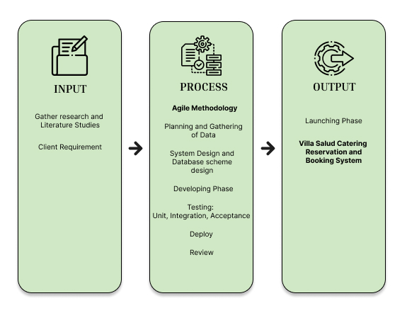

The researchers used the Input-Output Process (IPO) Model to conceptualize all the variables within the system. Based on the information and client requirements, the researchers will analyze, design, and develop the Villa Salud Catering Reservation and Booking System during the process, this represents the system development phase.

The system development follows the Agile Methodology, beginning with planning and data gathering to understand the needs of Villa Salud. This will include designing a systematic database schema in the system design phase, thus ensuring that the flow of information is appropriate. In the development phase, core functionalities will be implemented and tested in several stages, for instance unit testing, integration testing, and acceptance testing, in order to ascertain system reliability. The tested system will then be deployed for real-world usage and put under review based on its performance.

The output of this process is a fully functional and automated catering reservation and booking system for Villa Salud. This system will improve the event reservations, make the scheduling process efficient, and ensure that the overall customer experience is enhanced. It will also give a better way of organizing bookings by the management so that manual workload and errors are reduced.

**1.1.3 Theoretical Framework**

In recent years, a lot of attention has been paid to the creation and integration of information systems for catering services. Numerous studies highlight how technology may revolutionize business competitiveness, operational effectiveness, and consumer satisfaction.

For example, JETIR (2021) emphasizes how well online catering management systems work for scheduling, resource management, and resolving issues with catering services. According to a study by Maringa and Maringa (2023), the system's capacity to automate these procedures results in more efficient operations and fewer inefficiencies. This highlights how information and communication technology (ICT) may improve catering information systems (CIS). The study showed how digital interventions, like stock control and recipe costing systems, enhanced operational effectiveness and raised service standards in Kenyan hotels.

Similaa (2024) investigated the possibilities of digital solutions such as MarketMan for inventory management and CaterZen for data-driven menu creation, which significantly increased customer happiness and decreased waste.

Research on event systems, like Verana (2024), shows how technology makes difficult jobs like scheduling, budget management, and maintaining smooth communication with guests easier. These duties are relevant to Villa Salud's demands.

Furthermore, the International Instruction (2022) demonstrated how algorithm-driven systems might enhance quality monitoring, which could be modified to satisfy Villa Salud's catering services' requirements for food and service.

Table 1. Stages of Diffusion of Innovation Theory Table

|  |  |
| --- | --- |
| **Stages of Diffusion of**  **Innovation Theory** | **Integration of Villa Salud catering reservation and booking system** |
| Knowledge Stage | Users become aware of the system and its features. |
| Persuasion Stage | Users develop opinions about the system based on its perceived advantages. |
| Implementation Stage | The system is fully deployed and integrated into operations. |
| Integration and Compatibility Stage | Design the system to compliment with the existing processes of Villa Salud. Ensuring the compatibility of the system with different platforms |
| Observation Stage | Provide updates on system, whether a positive or negative feedback. |

**1.2 TECHNICAL BACKGROUND**

**1.2.1 Equipment/Hardware**

Table 2. Equipment/Hardware - Admin

|  |  |
| --- | --- |
| **ADMIN WORKSTATION** | |
| Processor | Intel Core i5 or higher (or AMD equivalent) |
| Memory | 8GB RAM or higher |
| Storage | 500GB SSD or higher |
| Display | 1080p resolution monitor |
| Network | Stable internet connection with at least 10 Mbps speed |

Table 3. Equipment/Hardware – Patron

|  |  |
| --- | --- |
| **PATRON** | |
| Device | Smartphone, tablet, or desktop/laptop |
| Browser | Compatible with Chrome, Firefox, Safari, or Edge |
| Network | Stable internet connection (at least 5 Mbps) |

**1.2.2 Software**

Table 4. Software Requirement - System

|  |  |
| --- | --- |
| **SYSTEM** | |
| Database | MySQL (version 8.0 or higher) |
| Backend | PHP (version 8.1 or higher) or other server-side languages |
| Frontend | HTML5, CSS3, JavaScript (with frameworks like React or Vue.js) |
| Web Serve | Apache or Nginx |
| Operating System for Server | Ubuntu Linux or Windows Server 2019/2022 |

Table 5. Software Requirement – Admin

|  |  |
| --- | --- |
| **ADMIN** | |
| Operating System | Windows 10/11 or macOS Monterey/Ventura |
| Browser | Google Chrome or Mozilla Firefox (latest version) |
| Additional Tools | Spreadsheet software (e.g., Microsoft Excel or Google Sheets) for reporting |

**1.2.3 Peopleware/Manpower**

The roles of system administrator, admin staff, customers (patron) and, developer/technical support team are needed in order to manage and execute the system effectively. System administrator in the one responsible for installing, maintaining and, updating the system. Also, the system administrator manages server-side configurations, database backups and, security. The admin staff on the other hand, is the one responsible for managing inquiries, reservations, and payments within the system. He also uses the admin dashboard to update reservation statuses and generate reports. The customers are the end-users of the system who will use the web interface to make reservations, view availability, and submit inquiries. Lastly, the developer/technical support team provides technical assistance during system implementation and handles bug fixes, updates, and system enhancements when necessary.

**1.2.4 Network Infrastructure/Architecture**

**1.2.5 Storage, Backup and Recovery Procedure**

Store data in an encrypted MySQL database hosted on a secure server. This is a good procedure because it keeps your data safe from unauthorized access. Encryption makes sure that even if someone tries to access the data, they won’t be able to read it without proper permissions. Hosting the database on a secure server adds another layer of protection with tools like firewalls and strong passwords. This setup ensures that important information like customer details and payments is protected at all times.

Schedule full backups every Sunday at 2 AM and incremental backups every 24 hours. This backup method is good because it ensures you always have a complete copy of your data (full backup) while also saving time and storage space by only backing up changes made since the last backup (incremental backup). By doing full backups weekly and incremental backups daily, your data is consistently protected without slowing down the system. Scheduling backups during off-hours (2 AM) avoids interruptions for users and keeps the system running smoothly during busy times.

Restore from the most recent full backup and apply incremental backups to minimize data loss. This recovery process is good because it helps you get the system back up and running quickly after a failure. Using the most recent full back up as a starting point means you can restore the main data easily, while the incremental backups ensure you don’t lose any updates made after the last full backup. This minimizes downtime and ensures that the system is as up-to-date as possible when restored.

**1.2.6 Security Procedures**

Data encryption will be implemented in building the system as it helps the system to handle sensitive data as well as to protect the data and our customer including patron (customers) and admin.

Strong password policy will be implemented in order to make sure that the admin log-ins will be safe and secure. This gives the capability for the admins to make their account more secure.

Implementing access control in the system allows the team to make sure that its database will be secured. Having access control to the system, especially in the database will make sure that the database where we store critical data like client information’s, both admin and patron.

HTTPS involves three (3) major things about security. Confidentiality, integrity and, authenticity. These three (3) topics focuses on the following; confidentiality for making sure that sensitive or important data will not be easily readable through encryption, integrity ensures that only the server can read what the system sends and only the system can read what the server sends, authenticity is the one that verifies that the system is talking to the server directly

**1.2.7 Policies and Procedures**

**1.3 PROBLEM ANALYSIS**

**1.3.1 Fishbone Diagram**

Figure 2. Fishbone Diagram

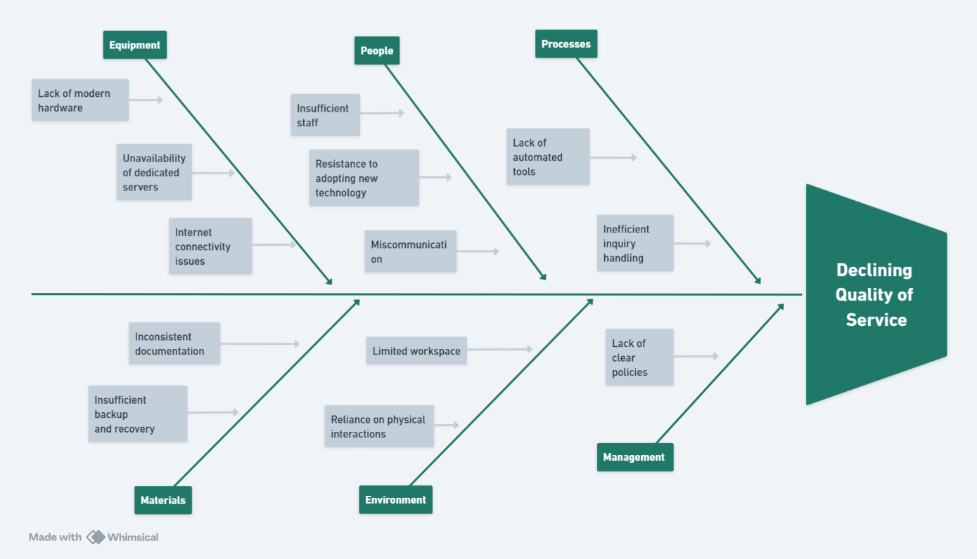

**1.3.2 Problem and Solution Statement**

Villa Salud, a well-known reception hall, faces significant operational challenges due to its outdated procedures for scheduling, menu management, and reservations. These methods have resulted in issues such as double bookings, inadequate planning, inaccurate records, data loss, and delays in responding to client inquiries, ultimately eroding customer trust and satisfaction. Addressing these inefficiencies is critical for Villa Salud to remain competitive in the evolving catering industry.

To overcome these problems, this study proposes the development of the Villa Salud Catering Reservation and Booking System, an automated platform designed to streamline operations and improve service quality. The system will include a centralized database for storing all event details and client information, ensuring accurate record-keeping. It will also feature automated inquiry management, online reservation functionality, email notifications, and real-time reservation tracking to prevent double bookings and reduce discrepancies. Additionally, the system will incorporate automated data backup solutions, cloud storage options for enhanced security, and efficient scheduling tools with reminders to optimize workflows. By implementing these solutions, the system aims to modernize Villa Salud's operations, prevent data loss, reduce processing delays, and elevate customer satisfaction, ultimately positioning the business for sustained success in a competitive market.

**1.3.3. Problem – Requirements Matrix**

Table 1. Problem – Requirements Matrix

|  |  |
| --- | --- |
| **IDENTIFIED PROBLEMS** | **REQUIREMENTS TO ADDRESS THE PROBLEMS** |
| **Inconsistency of record** | Develop a centralized database to store all events details and client information. |
|  | Implement a user-friendly interface for accurate data entry. |
|  | Provide automated notifications and confirmations to avoid double bookings. |
|  | Establish real-time record updates to prevent discrepancies. |
| **Loss of Backup data** | Implement automated data backup solutions |
|  | Develop a data recovery protocol to retrieve lost information |
|  | Ensure data encryption and protection against unauthorized access. |
| **Delay of Process** | Develop an automated inquiry management system. |
|  | Introduce an online reservation and booking feature. |
|  | Implement an efficient scheduling system with reminders. |
|  | Optimize workflow processes through task automation |

**1.4 PURPOSE AND DESCRIPTION**

The purpose of this study is to design and develop a Catering Booking and Reservation System specifically for Villa Salud, a well-known events venue in Taguig. This system aims to address operational inefficiencies and improve the overall customer experience by automating key processes such as inquiry management and reservation scheduling. By providing a modern, user-friendly interface for both patrons and admins, the system seeks to streamline Villa Salud's operations while ensuring a seamless booking process for its clients.

The proposed system is designed to solve three critical issues identified in Villa Salud's current manual operations: inconsistency in record-keeping, delays in processing inquiries, and risks of data loss. Through the implementation of this system, Villa Salud will benefit from centralized data management and automated scheduling. Additionally, patrons will have the convenience of booking and managing their reservations online, ensuring transparency and trust between Villa Salud and its customers.

Key features of the system include:

* Admin Dashboard: For managing inquiries, reservations, and payments efficiently.
* Reservation Management Module: To avoid double bookings and allow flexible rescheduling or cancellations.
* Customer Portal: Allowing patrons to check availability, submit inquiries, and receive automated email confirmations.

The system’s development is guided by principles of usability, scalability, and efficiency, ensuring that it not only meets the current needs of Villa Salud but also accommodates future growth.

**1.5 SPECIFIC OBJECTIVES**

The specific objectives of the study are as follows:

1. To develop an inquiry management module
   * Allowing admins to categorize and respond to patron inquiries quickly.
   * Automating notifications for patrons regarding the status of their inquiries.
2. To create a centralized reservation management system
   * Enabling admins to manage event schedules efficiently, avoid double bookings, and track available dates.
   * Allowing patrons to view available dates, book reservations, and modify or cancel their bookings.
3. To enhance data security and backup procedures
   * Ensuring that reservation, inquiry, and payment records are safely stored and regularly backed up.
4. To improve operational efficiency and reduce delays
   * Automating manual processes to save time and reduce errors.
   * Providing real-time data access for decision-making and planning.
5. To develop a user-friendly interface for patrons and admins
   * Ensuring an intuitive design for smooth navigation.
   * Providing training resources and documentation to facilitate system adoption.
6. To generate reports for admin use
   * Allowing admins to analyze booking trends, payment data, and system performance.
   * Supporting strategic decision-making based on real-time and historical data.

**1.6 SCOPE AND LIMITATIONS**

**Scope**

This study aims to develop a booking and reservation system of catering service that Villa Salud offers. This system specifically aims to provide help in this area: reservation of events; organization of offered packages; automation of checking and scheduling for events; tool and feedback for reporting and summarization. With the system it can help both clients and staff of Villa Salud. On the client's side, it will be much easier for them to check and inquire for their questions and inquiries. For the staff’s side, it provides an easy but powerful tool to use to ease up their jobs, therefore providing more and greater services to the customers.

**Limitations**

This study aims to focus on Villa Salud catering services only. This system will be enough to be developed and studied for the amount of time we researchers have. Limited time and resources, such as money and manpower contribute to the limitations of the development of this system. Tool and knowledge are the other half of the great contributor for the limitation. Lacking knowledge of other programming languages and tools causes limitations for us developers. Data testing is limited, having just enough data provided by the owners and managers to us, which is also a cause of having not enough time.

**CHAPTER 2**

**REVIEW OF RELATED LITERATURE**

1. **Event Management Systems**

It was agreed by MDPI (2022) that planning is created to aid the owner and the customers in managing and placing orders. Through the use of this system, the owner can track reservations and bookings, inquiries and payments of the customers. Data analysis resulted in the development of a set of tools and methods that have the potential to assist corporate event managers in the project risk management process. This set comprises a work breakdown structure (WBS) template, a risk breakdown structure (RBS), and a set of risk treatment and mitigation strategies for corporate events. These tools are innovative in the sense that they are based on and correspond to the phases of the event life-cycle rather than individual management domains, have not been developed in unison before, and can be utilized collectively for greater benefits

Discussed by Akshayaa Rani M (2023), technology is revolutionizing contemporary event catering, increasing productivity and visitor happiness. Data-driven menu customization is made possible by tools like CaterZen, and waste is decreased and supply chains are optimized by inventory management systems like MarketMan. Food preparation and presentation are improved by cutting-edge kitchen technologies including 3D food printing and robotic chefs. Wearable technology and mobile apps make it easier for employees to coordinate for flawless service. Digital menus and clever serving methods are examples of interactive dining technologies that enhance and customize the visitor experience. The paper emphasizes how crucial technology is to improving operational excellence and upgrading event catering. With the help of technological enhancements, it emphasizes the great help technology can give to the users thus, allowing to have better execution in terms of event management resulting in great user experience.

### **Catering And Food Service Technologies**

JETIR (2021) explored the use of online catering systems. Highlighting different kinds of catering like mobile catering, wedding catering, catering on ships and so on. The catering management system will help in maintaining the available people, resources and the timings well. It will help in solving the problems related to the catering at the events that are conducted. This catering management system will help in the smooth running of the business.

The study by Maringa and Maringa (2023) highlights the significance of ICT for competitiveness in a globalized market by examining how it improves Catering Information Systems (CIS) in Kenyan e-hotels. The study, which looks at operations across hotel star ratings, finds that important CIS components—such as food, drinks, conference, and rooming services—are heavily reliant on information flows. Automated mini-bars had the least influence, whereas recipe costing and stock control systems were the most successful ICT intervention areas. Rooming and conferencing came in second and third, respectively. The report highlights how important ICT is to streamlining hotel operations and enhancing service quality.

Akshayaa (2024) explores how digital tools revolutionize pre-event planning and enhance guest experiences, while Better Cater, Inc. (2024) discusses emerging trends like AI-driven resource management. This study emphasizes the use of technology, applying and using them as an advantage. Allowing the user to have better service to the customers.

Colleges and large-scale institutions have also embraced catering technology. IEEE (2022) examines campus catering systems designed to reduce inefficiencies during peak times. It showcases the range of use of Catering Information Systems (CIS) or any other related online services like booking and reservation services. This shows the flexibility of system. This study shows that even college campus can use this type of system and can show you great and helpful results.

### **Customer Satisfaction Through Technology**

Verana (2024) claimed that as an event planner, you know how challenging it can be to organize and run successful events. From managing budgets to coordinating schedules and communicating with attendees, many aspects must be considered. But with the increasing role of technology in event management, it has become more streamlined, efficient, and effective. In her article:Role of Technology in Event Management: A Guide for Event Planners, it has been explored how technology can support you in planning, promoting events, and executing events that leave a lasting impression on customers.

Meanwhile, ThaiJo (2024) emphasizes the role of ICT in increasing loyalty through personalized customer interactions and clear communication. With the help of technology, it prioritizes the means of making things easier as well as processes. Meaning to say, because of the use of technology it gives an edge to the users to have better experience in the system allowing to have a good results and feedback from them, also making things easier for them and making good impressions that the system brings to the customer.

### **Small Business Automation**

“How Manual Processes Are Hurting Your Business” an article developed in 2022 by Frank Tilleli. Automation encompasses a wide range of easy-to-implement digital tools and platforms that can significantly streamline and improve various business processes, particularly tedious tasks like data entry and verification. If you haven't made the move to automation, you could be hurting your company more than you realize. Manual processes have become a hindrance, putting those who use them further behind their competitors and limiting their ability to create valuable, efficient workflows.

Khwunnak et al. 's (2023) study focuses on a website that serves as a reservation system for local business owners in Nong Bua Lam Phu Walking Street. The method, which targets 170 small company owners, attempts to simplify reservations for sales spaces while improving convenience and cutting down on travel expenses. Overall quality ratings for the website were high (M=3.78, SD=0.59), and the most useful component was the user interface. Additionally, the level of satisfaction among entrepreneurs was very high (M=4.00, SD=0.69), indicating that it had been successful in increasing accessibility and efficiency for local vendors. The importance of digital technologies in assisting local companies is emphasized by this study.

The International Journal of Instruction (2022) further illustrates how algorithm-driven systems improve quality monitoring, a concept adaptable to food and service standards in catering. Having a system that focuses on making the best possible service to the customer gives you a good look and advantage as a business owner, especially nowadays that innovation and technology is a must. It is like a privilege to have that once you have it, it will give you so much edge to you competitors.

**Synthesis**   
 The reviewed literature demonstrates how digital solutions transform event management, catering services, customer satisfaction and small business operations. Each study contributes insights into how Villa Salud Catering Services can adopt automation and customer-centric technology to enhance efficiency and competitiveness. The literatures mentioned and used in this chapter was able to determine different topics and factors needed to fully enhanced and develop the system for Villa Salud. Focusing on main ideas and topic to relate for research study, we are able to determine previous studies and use it as a guide and answer questions in developing the system. This research seeks to bridge the gap in existing literature by developing a tailored platform that meets the unique needs of Villa Salud.

**CHAPTER 3**

**METHODOLOGY**

**3.1 REQUIREMENT ANALYSIS**

**3.1.1. Features Matrix**

Table 2

|  |  |  |
| --- | --- | --- |
| **Feature** | **Description** | **Requirements** |
| Inquiry Management | Allows admins to manage customer inquiries, including responding, categorizing, and converting inquiries into reservations. | Admin login, inquiry submission forms, email notification system. |
| Reservation Management | Admins can view available and reserved dates, update reservations, and avoid double bookings. | Admin dashboard, date-picker, reservation status tracker. |
| Email Confirmation | Automatically sends email confirmations to customers after inquiries or reservations. | Admin login, email server integration, confirmation templates. |
| Booking System | Admin can select available dates depending on the date inquired by the patron. | Initial inquired date from patron |
| View Reservation | Admin and Patrons can view their reservation details, including date, time, menu, and payment status. | Admin login, database connection for reservation details. |
| Cancel/Reschedule Reservation | Patrons and Admin can cancel or reschedule their reservations through an easy-to-use interface. | Admin login, date-picker for rescheduling, reservation ID validation. |
| Receive Notifications | Patrons receive email or SMS updates about their reservations or inquiries. | Email notification system, SMS gateway (optional). |
| Admin Dashboard | Centralized dashboard for admins to manage reservations, generate reports, and check system status. | Admin login, reporting tools, summary views for reservations, inquiries, and payments. |
| Payment Processing | Tracks payment details, including type (down payment/full payment), amount, and payment date. | Payment table in the database, support for multiple payment types (ENUM: 'down', 'full'). |
| Activity Logs | Records admin and patron actions (e.g., reservations, inquiries, and payments) for tracking purposes. | Database table for activity logs, timestamp recording, admin ID/patron ID linkage. |

This table represents all the main features our system has. This explains how system works, what it means and what it’s called. This also shows the requirements needed to meet the feature or the capabilities of the system. It can also show who is involved in the feature.

**3.1.2. Use Case Diagram**

Figure 3. Use Case Diagram

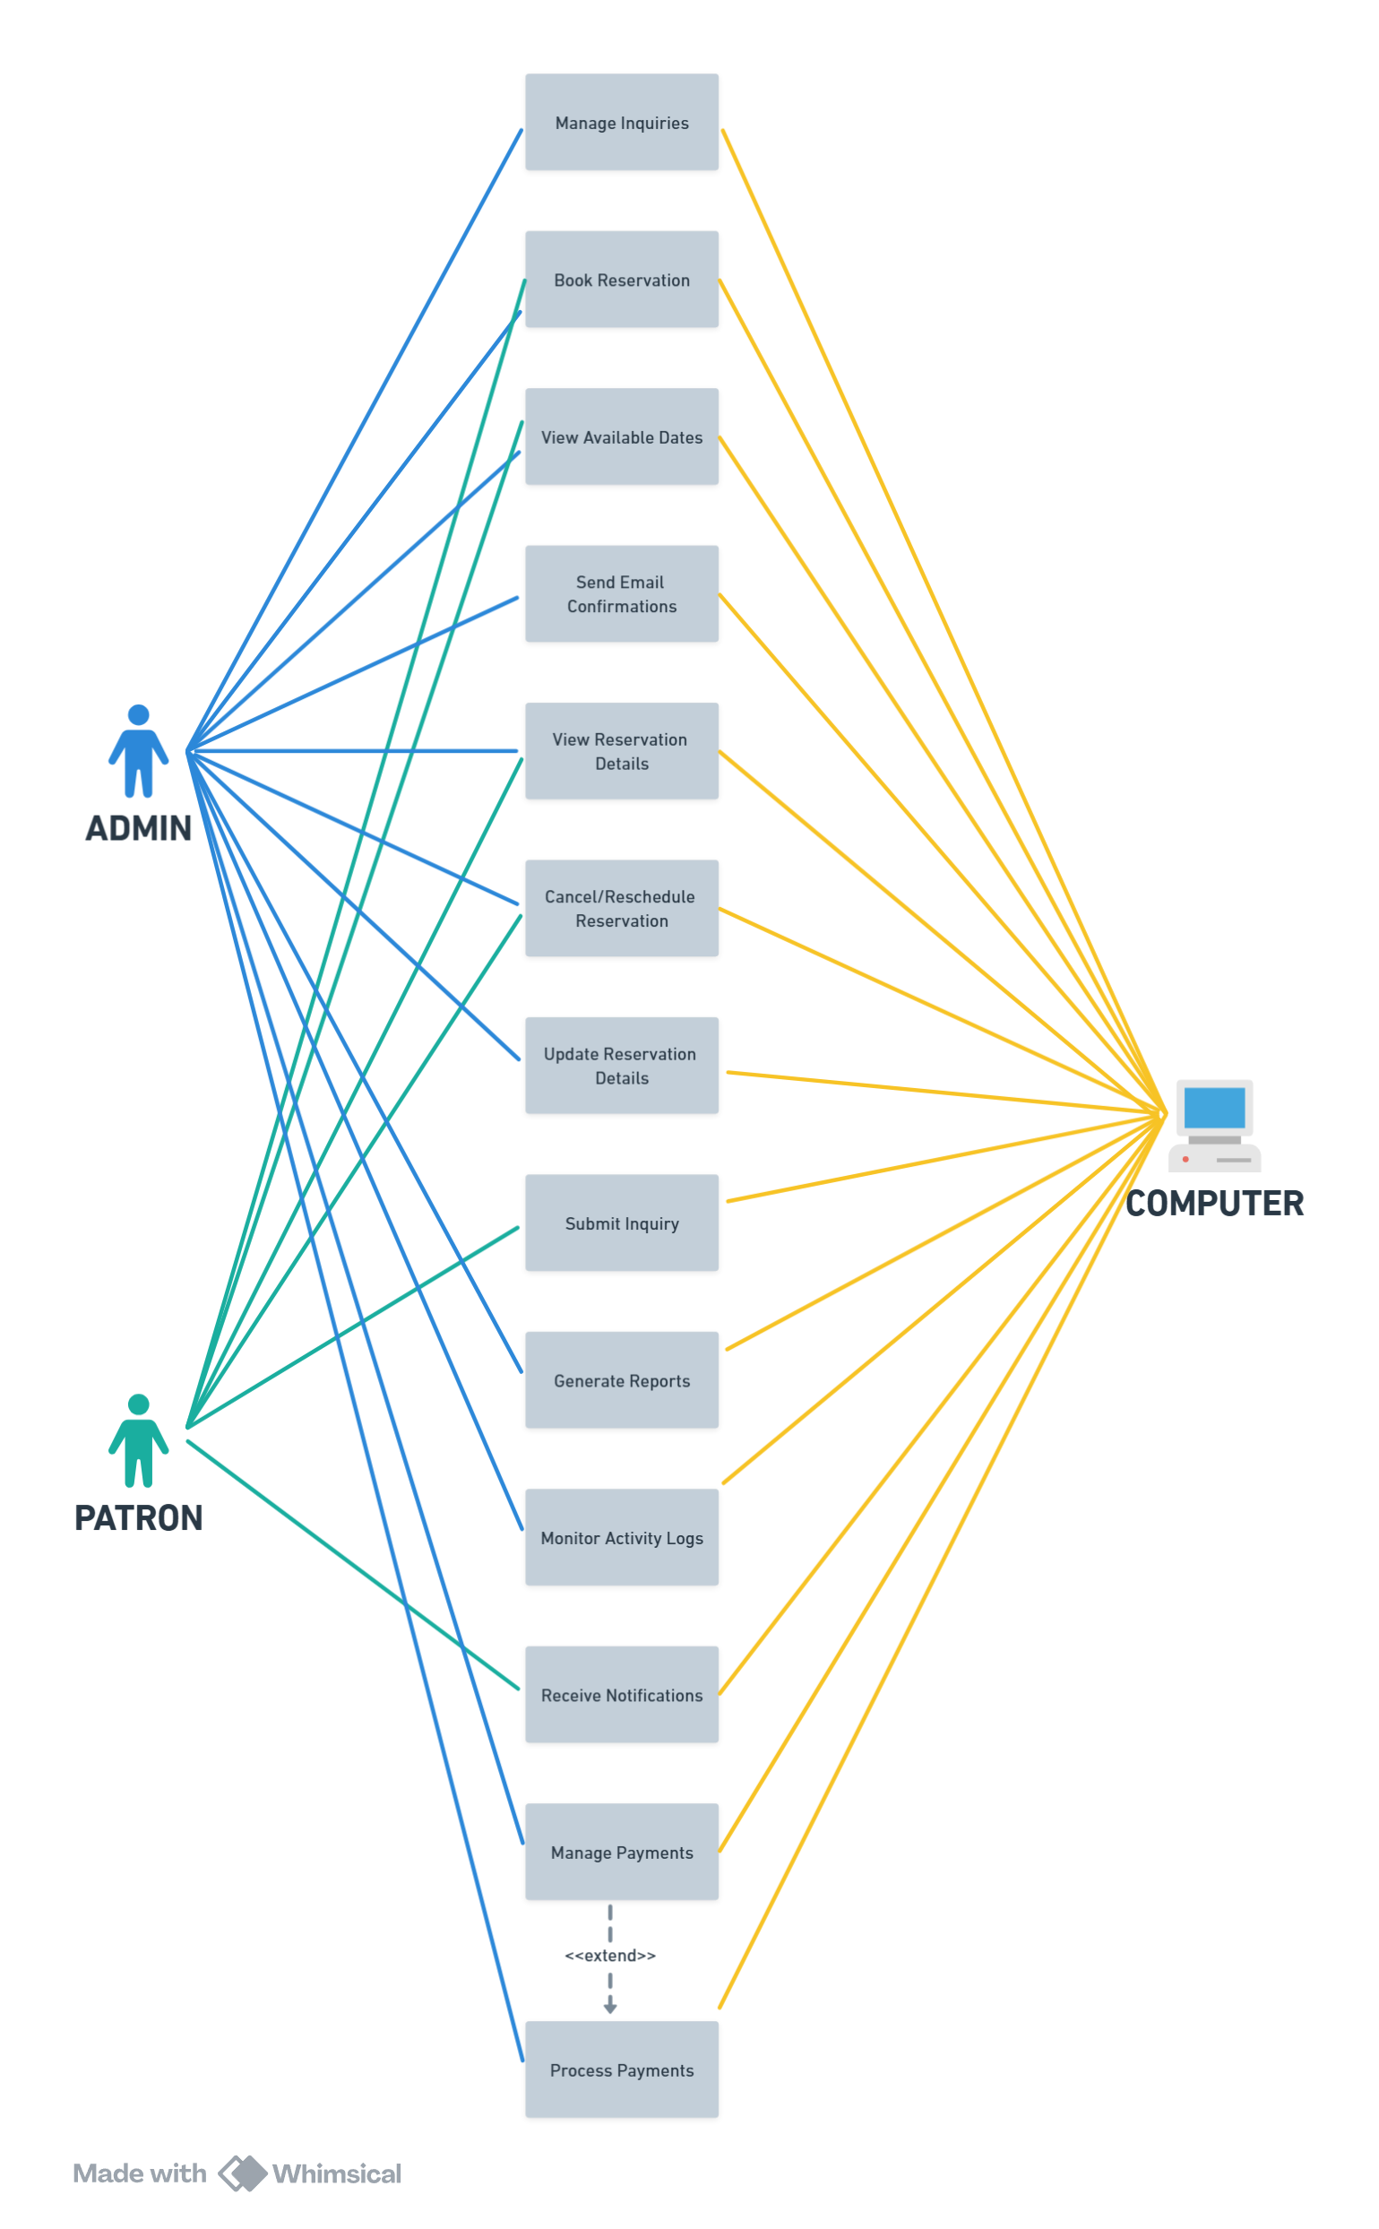

Figure 4. Detailed Use Case Diagram – Inquiry Management

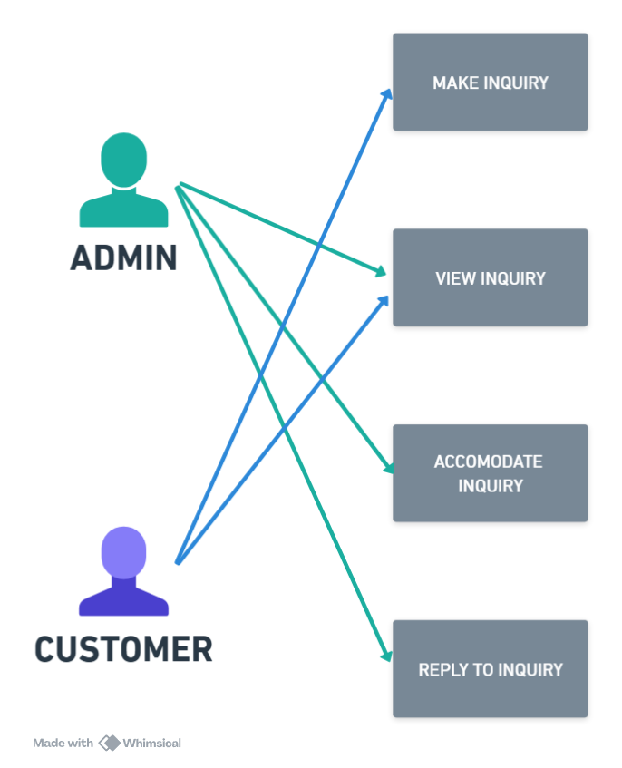

Figure 5. Detailed Use Case Diagram – User Management

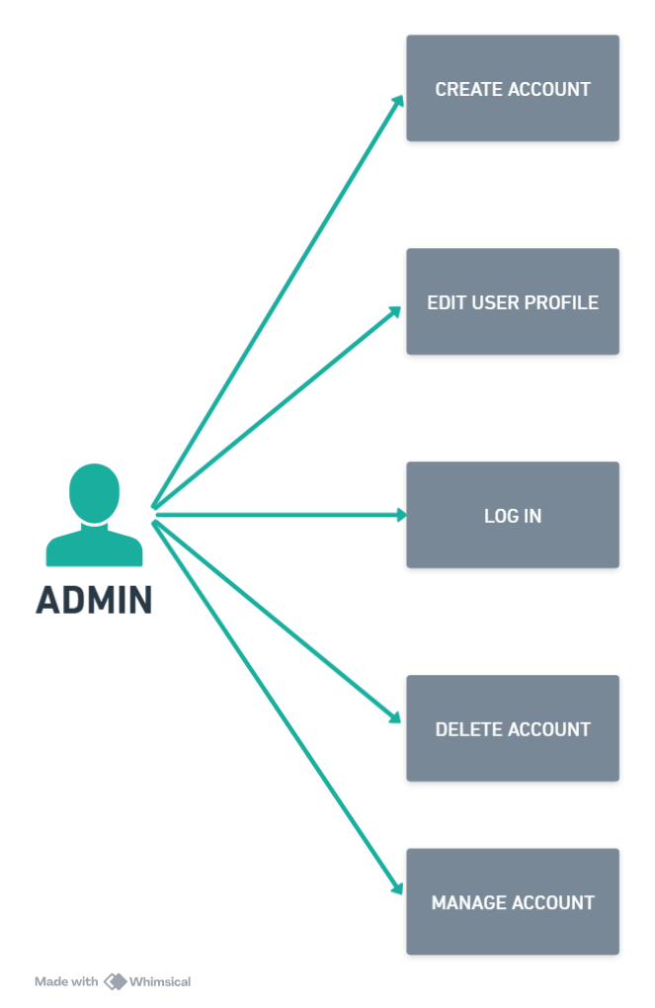

Figure 6. Detailed Use Case Diagram – Reservation Management

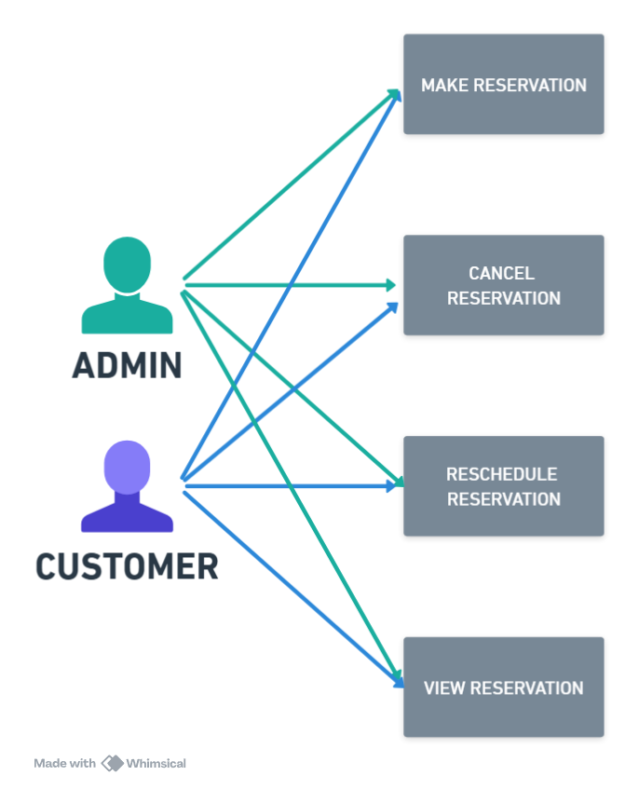

Figure 7. Detailed Use Case Diagram – Payment Process

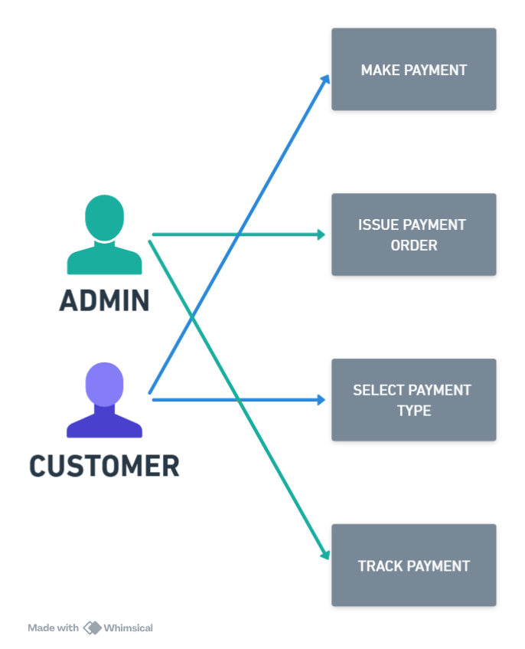

**3.1.3. Use Case Report**

Table 3

|  |  |
| --- | --- |
| **Use Case Name:** | **Inquiry Management** |
| Actors | Admin and Patron |
| Description | This use case describes the process by which patrons submit inquiries about events and how the admin manages these inquiries by categorizing and responding to them. |
| Preconditions | 1. Admin must be logged into the system. 2. Patron must access the inquiry submission form. |
| Main Flow | 1. Patron submits an inquiry through the inquiry form, providing event details (e.g., date, type of event, expected number of guests). 2. System records the inquiry and notifies the admin. 3. Admin views a list of inquiries on the dashboard. 4. Admin responds to the inquiry through the system (via email or direct message). |
| Alternative Flow | If an inquiry lacks required information, the system prompts the patron to complete the missing fields. |
| Postconditions | 1. Inquiry is either responded to or marked as pending. 2. Patron receives a response notification. |

Table 4

|  |  |
| --- | --- |
| **Use Case Name** | **User Management** |
| Actors | Admin |
| Description | This use case allows the admin to manage user accounts, including creating, updating, and deleting user profiles. |
| Preconditions | Admin must be logged into the system with sufficient privileges. |
| Main Flow | 1. Admin accesses the user management module. 2. Admin can perform the following actions: 3. Create a new user account by entering details (e.g., name, email, and role). 4. Update an existing user’s information. 5. Deactivate or delete a user account. 6. System saves the changes made by the admin. |
| Alternative Flow | If the user account already exists, the system notifies the admin and prevents duplicate entries. |
| Postconditions | User account details are successfully updated in the database. |

Table 5

|  |  |
| --- | --- |
| **Use Case Name** | **Reservation Management** |
| Actors | Admin and Patron |
| Description | This use case outlines the processes for creating, updating, canceling, or rescheduling reservations. |
| Preconditions | Admin or patron must be logged into the system. |
| Main Flow | 1. Admin logs in and views the reservation dashboard. 2. Admin selects an existing reservation or creates a new one. 3. Admin enters or modifies reservation details (e.g., event date, food package, number of guests). 4. Admin confirms the changes. 5. System sends an email notification to the patron regarding the reservation update. |
| Alternative Flow | If the selected date is unavailable, the system prompts the patron or admin to choose another date. |
| Postconditions | Reservation details are saved, updated, or canceled. |

Table 6

|  |  |
| --- | --- |
| **Use Case Name** | **Payment Process** |
| Actors | Admin and Patron |
| Description | This use case describes how patrons make payments for reservations and how admins track payment statuses (e.g., full payment or down payment). |
| Preconditions | 1. Reservation must exist in the system. 2. Payment gateway must be active for processing. |
| Main Flow (Patron) | 1. Patron selects a reservation and chooses a payment type (full or down payment).  2. Patron enters payment details and confirms the transaction.  3. System processes the payment through the payment gateway.  4. System updates the reservation status based on the payment type. |
| Main Flow (Admin) | 1. Admin views the payment dashboard. 2. Admin verifies completed payments and updates records if needed. 3. Admin generates payment reports for internal records. |
| Alternative Flow | If the payment fails, the system notifies the patron and prompts them to retry. |
| Postconditions | 1. Payment status is updated (e.g., "Paid in Full," "Partially Paid"). 2. Patron receives confirmation of the successful transaction. |

**3.2 DESIGN SPECIFICATIONS**

**3.2.1. Activity Diagram**

Figure 8. Inquiry Management.

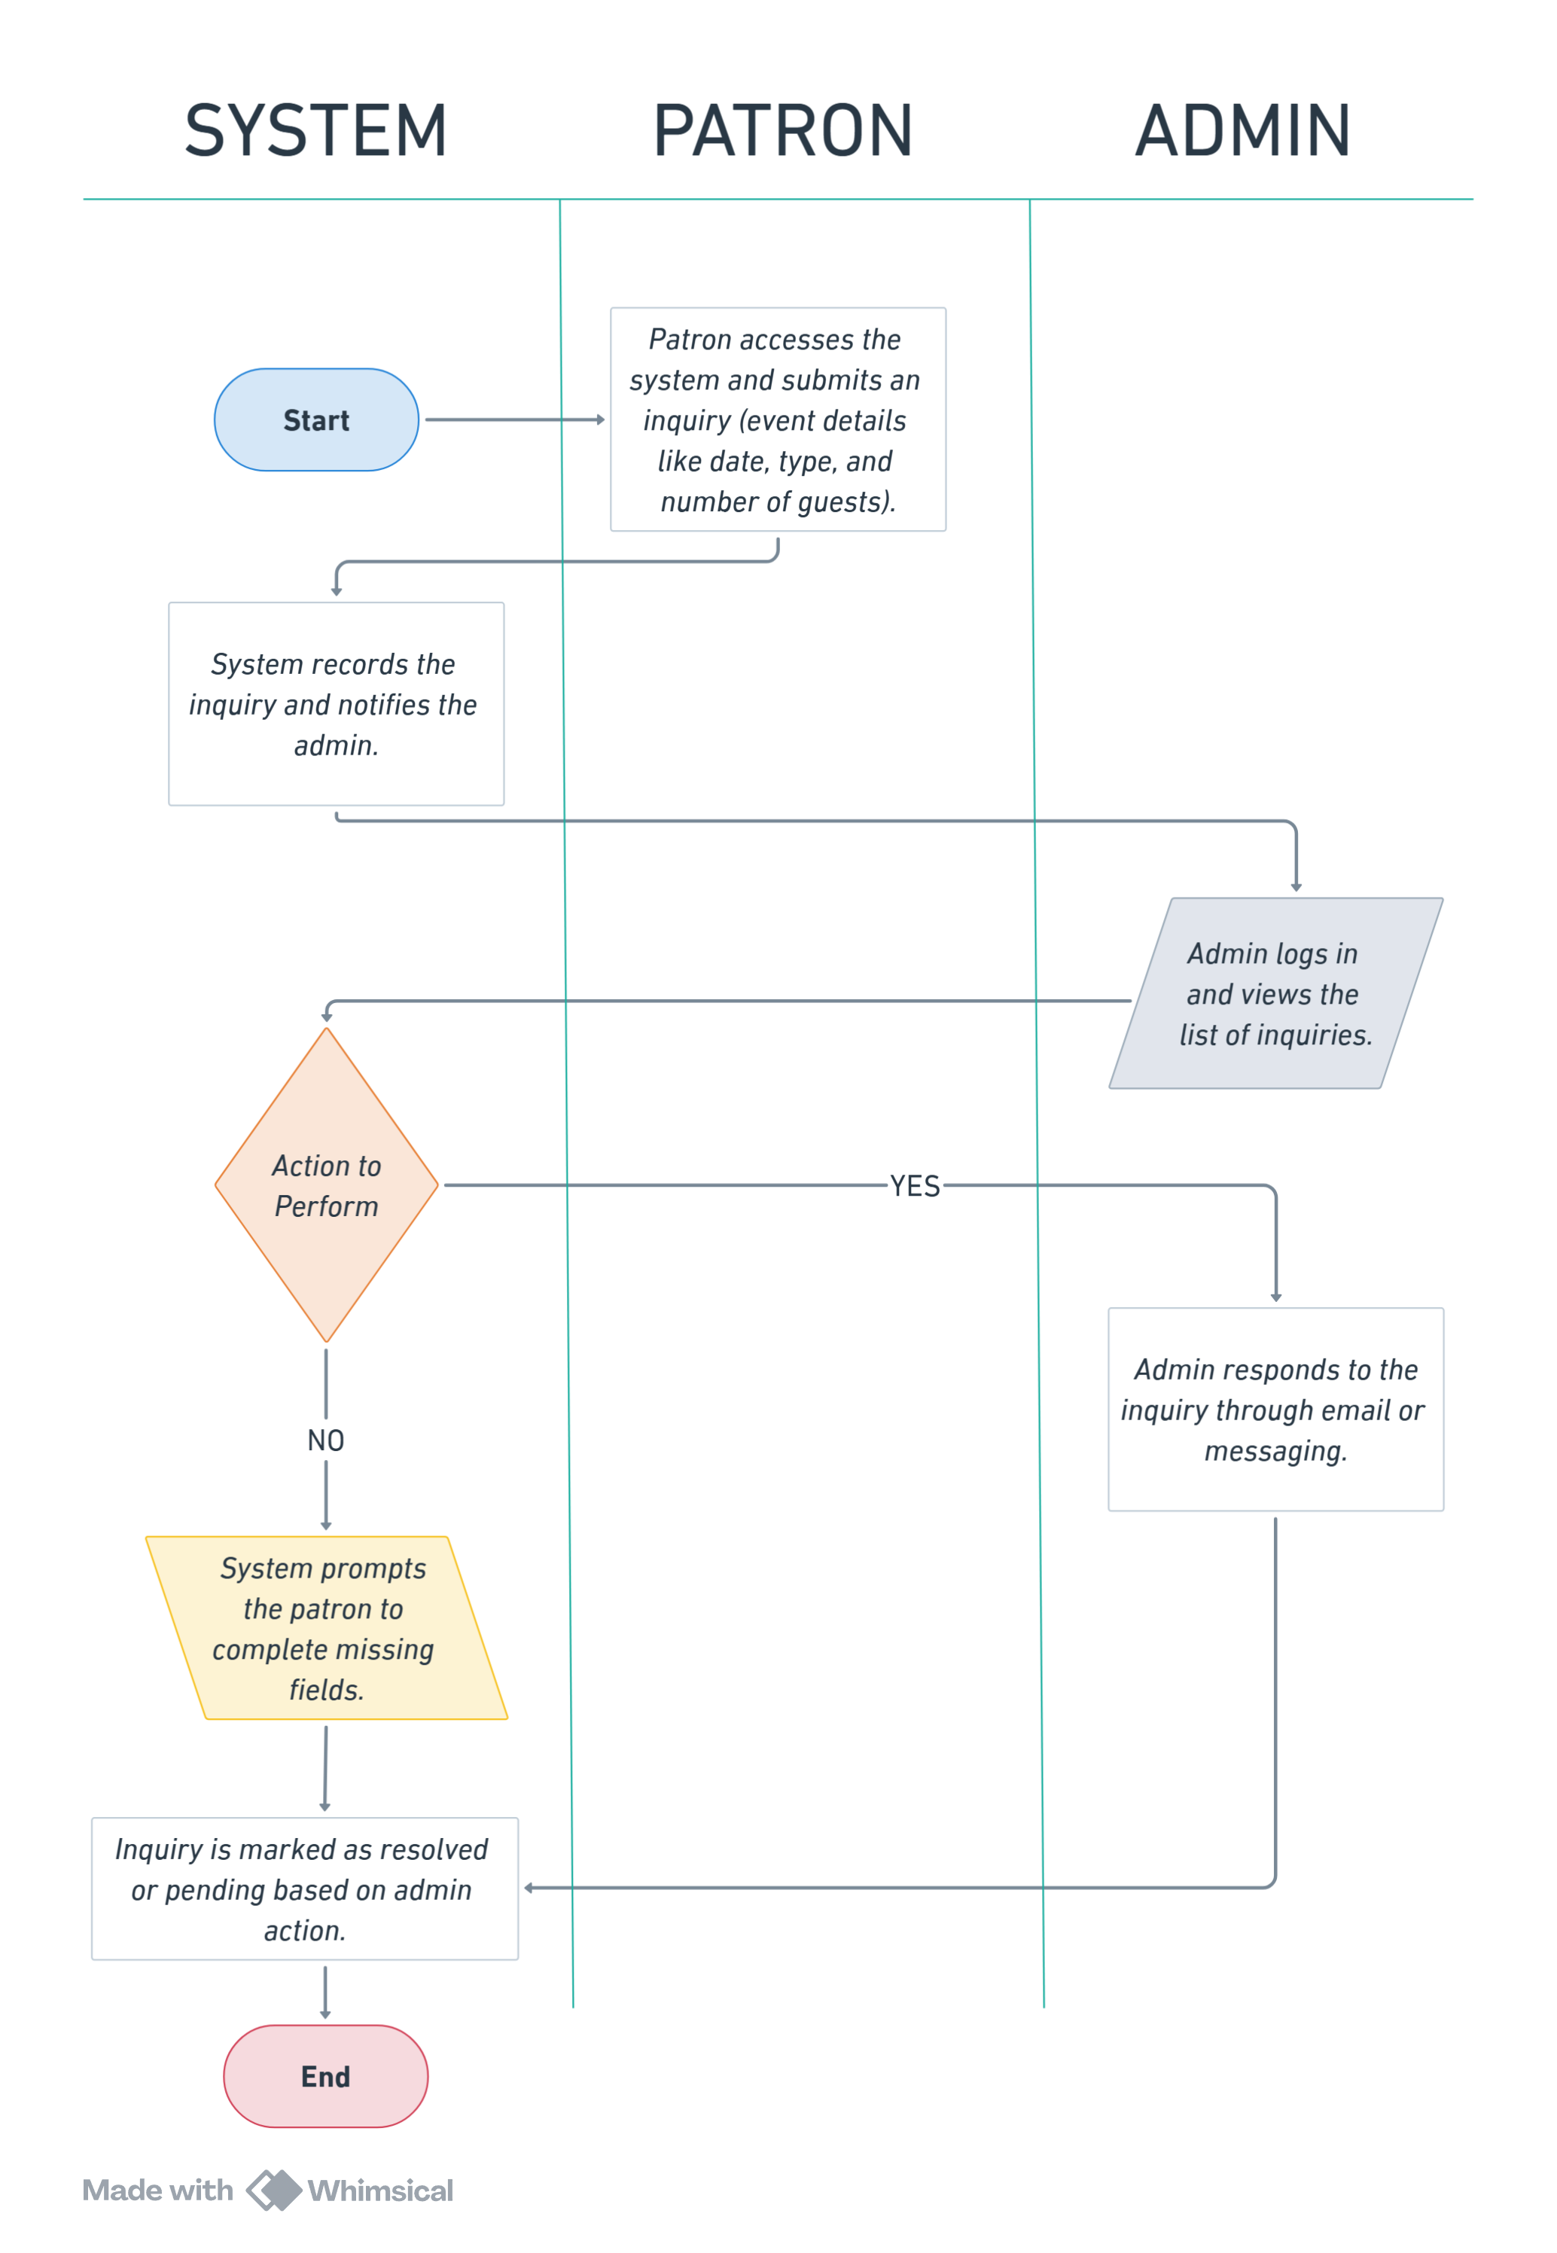

Figure 9. User Management.

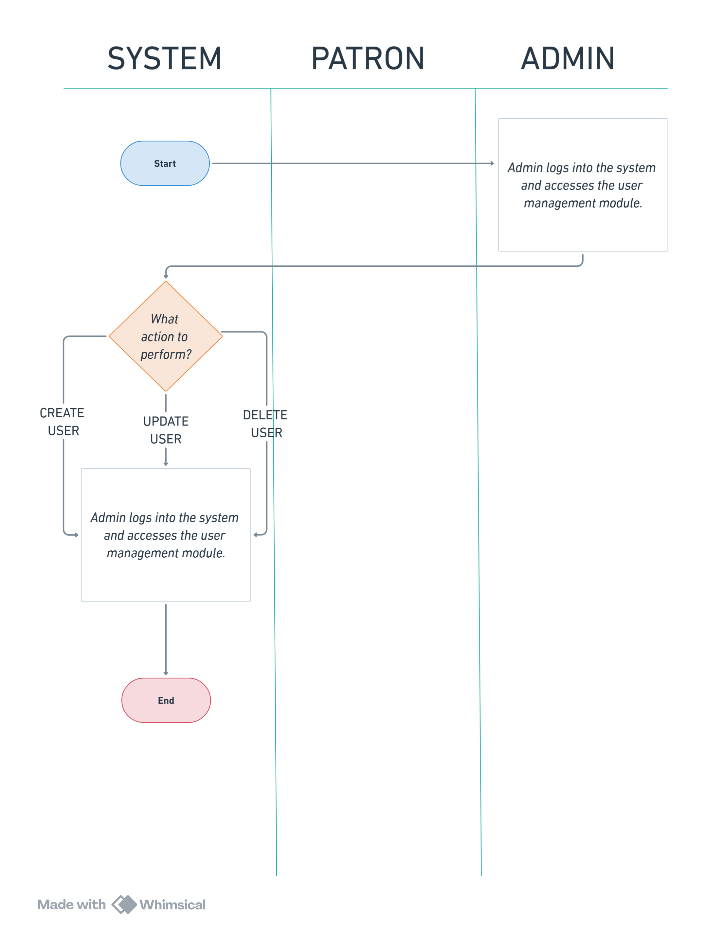

Figure 10. Reservation Management

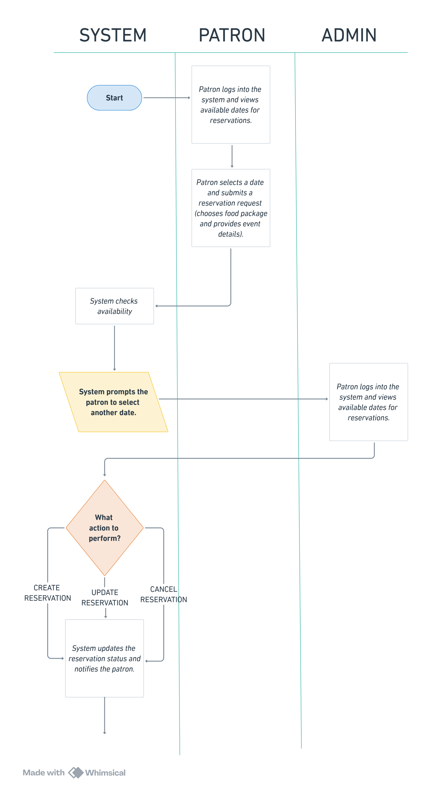

Figure 11. Payment Process

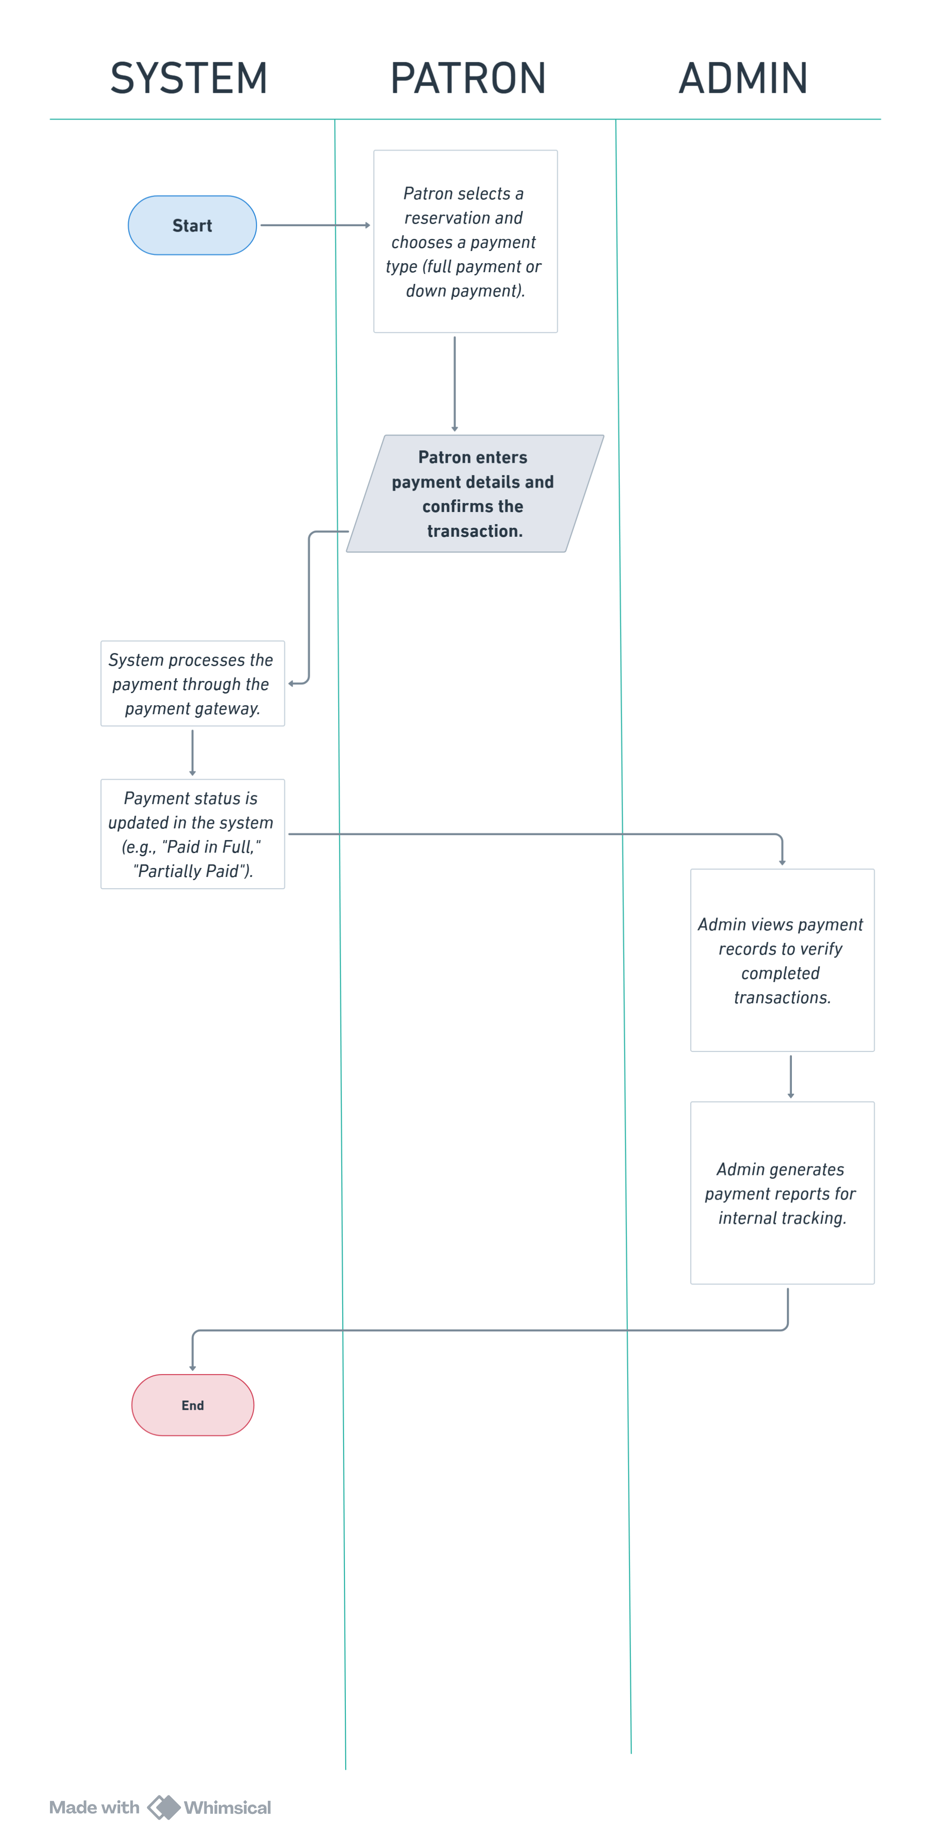

**3.2.2. GUI Design**

Figure 12. Landing Page

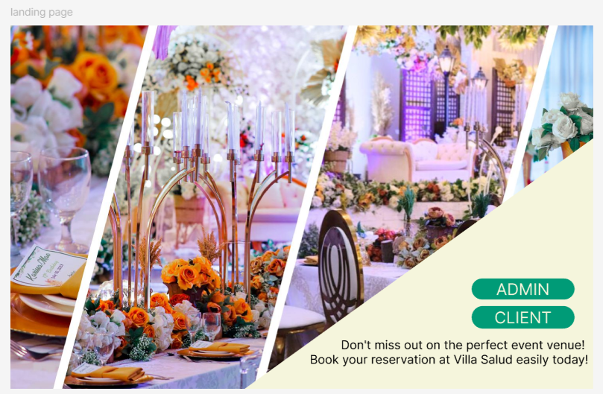

Figure 13. Admin Account Creation

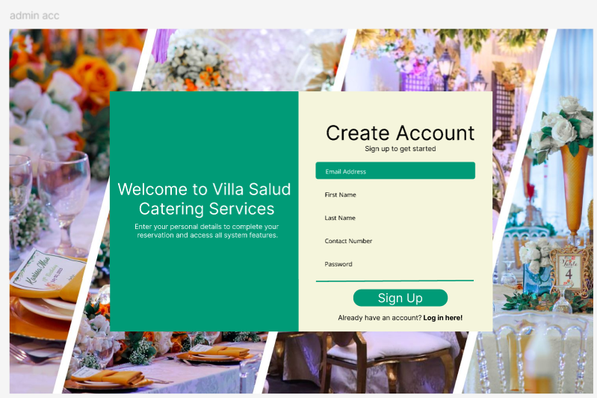

Figure 14. Admin Log in

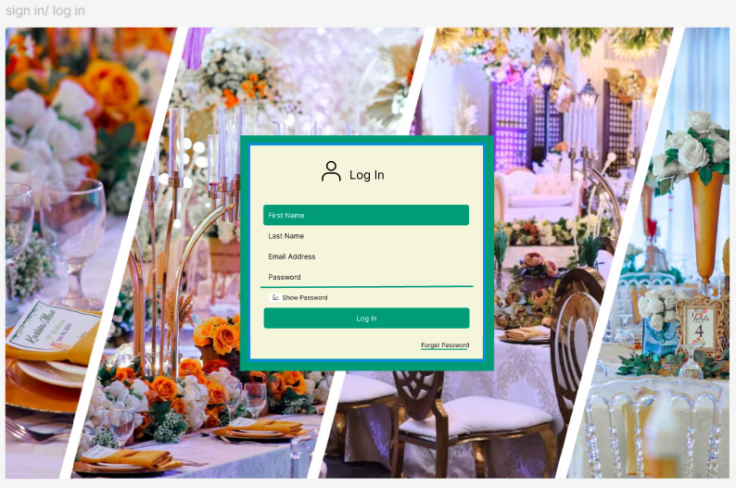

Figure 15. Inquiry Page

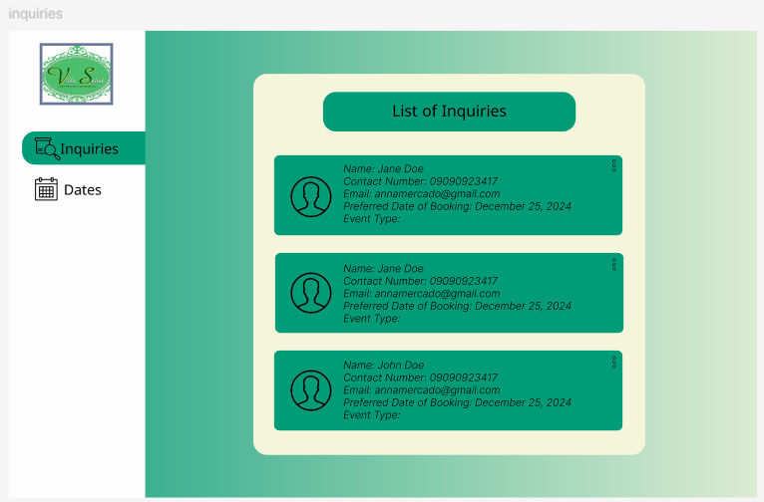

Figure 16. Dates Page

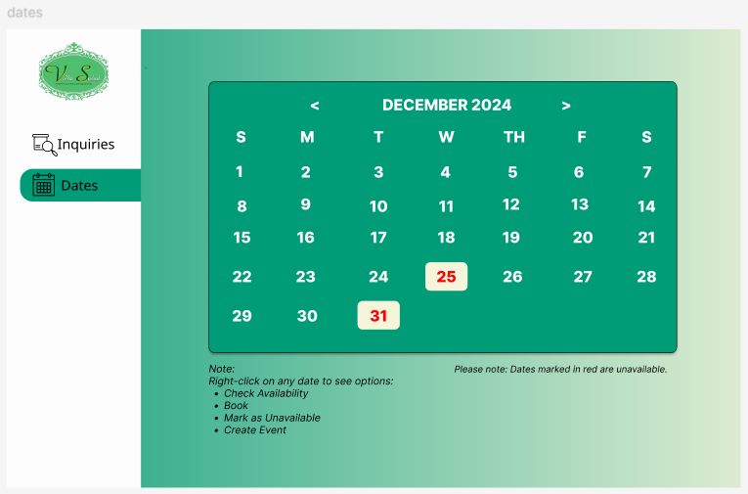

Figure 17. Patron’s Homepage

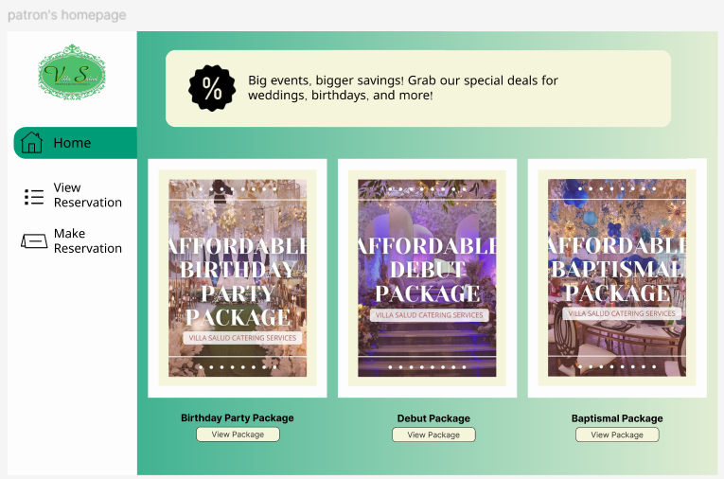

Figure 18. Patron: View Reservation

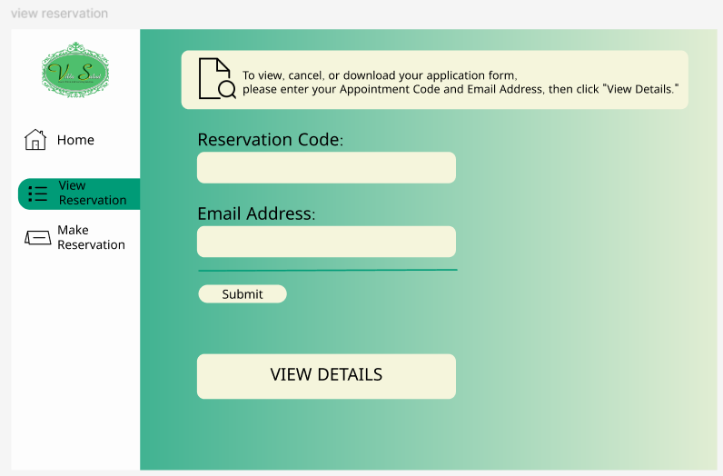

Figure 19. Creation of Reservation

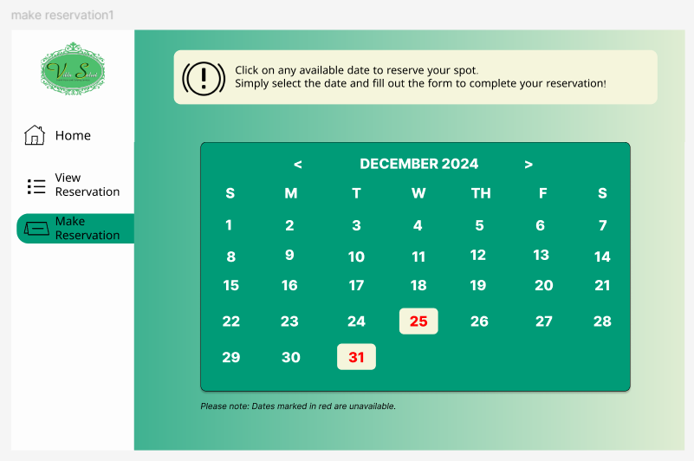

Figure 20. Initial Inquiry Questions

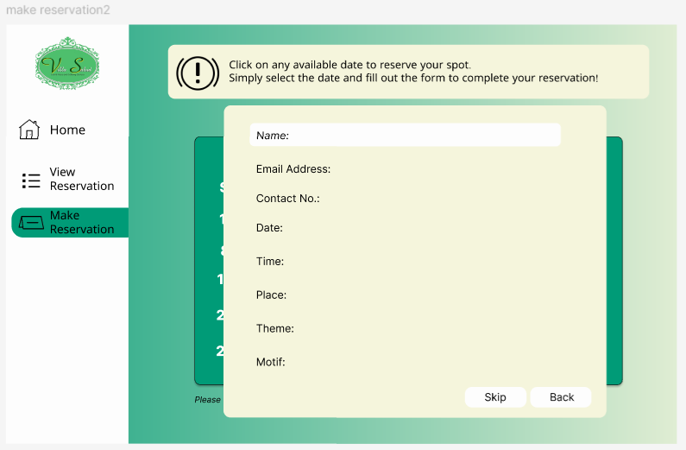

* + 1. **Database Schema**

Figure 21. Database Schema

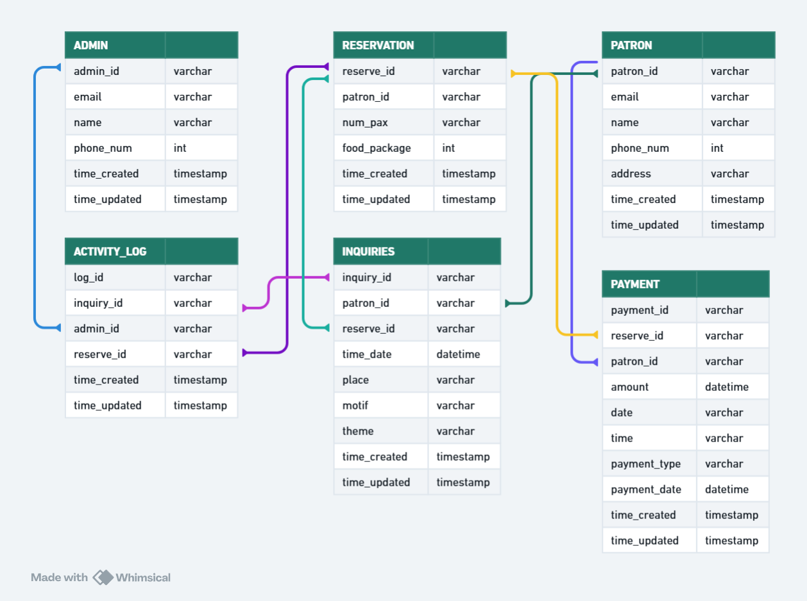

**3.2.4. Data Dictionary**

Table 7. Admin Table

|  |  |  |  |
| --- | --- | --- | --- |
| **ADMIN** | | | |
| Field Name | Data Type | Field Size | Description |
| id | INT |  | Description ID |
| admin_id | VARCHAR | 255 | Unique admin’s ID |
| email | VARCHAR | 255 | Admin’s email address |
| name | VARCHAR | 255 | Admin’s last name |
| phone_num | INT |  | Admin’s phone number |
| time_created | TIMESTAMP |  | Time for when the table has created |
| time_updated | TIMESTAMP |  | Time for when the table has been updated |

Table 8. Patron’s Table

|  |  |  |  |
| --- | --- | --- | --- |
| **PATRON (CUSTOMER)** | | | |
| Field Name | Data Type | Field Size | Description |
| id | INT |  | Description ID |
| patron_id | VARCHAR | 255 | Unique patron’s ID |
| Email | VARCHAR | 255 | Patron’s email address |
| name | VARCHAR | 255 | Patron’s last name |
| address | VARCHAR | 255 | Patron’s address |
| phone_num | INT |  | Patron’s phone number |
| time_created | TIMESTAMP |  | Time for when the table has created |
| time_updated | TIMESTAMP |  | Time for when the table has been updated |

Table 9. Reservation Table

|  |  |  |  |
| --- | --- | --- | --- |
| **RESERVATION** | | | |
| Field Name | Data Type | Field Size | Description |
| id | INT |  | Description ID |
| reserve_id | VARCHAR | 255 | Unique reservation’s ID |
| patron’s id | VARCHAR | 255 | Patron’s unique id |
| num_pax | INT | 255 | Number of persons that will attend |
| food_package | ENUM |  | What type of food package the customer will avail |
| time_created | TIMESTAMP |  | Time for when the table has created |
| time_updated | TIMESTAMP |  | Time for when the table has been updated |

Table 10. Inquiries Table

|  |  |  |  |
| --- | --- | --- | --- |
| **INQUIRIES** | | | |
| Field Name | Data Type | Field Size | Description |
| id | INT |  | Description ID |
| inquiry_id | VARCHAR | 255 | Unique event’s ID |
| patron_id | VARCHAR | 255 | Unique patron’s ID |
| reserve_id | VARCHAR | 255 | Unique reservation’s ID |
| time_date | VARCHAR | 255 | Time and date of the event |
| place | VARCHAR | 255 | Place of the event |
| theme | VARCHAR | 255 | The theme of the event |
| motif | VARCHAR | 255 | Motif of the event |
| time_created | TIMESTAMP |  | Time for when the table has created |
| time_updated | TIMESTAMP |  | Time for when the table has been updated |

Table 11. Payment Table

|  |  |  |  |
| --- | --- | --- | --- |
| **PAYMENT** | | | |
| Field Name | Data Type | Field Size | Description |
| id | INT |  | Description ID |
| pay_id | VARCHAR | 255 | Unique payment’s ID |
| reserve_id | VARCHAR | 255 | Unique reservation’s ID |
| patron_id | VARCHAR | 255 | Unique patron’s ID |
| amount | VARCHAR | 255 | Amount to be paid by the customer |
| date | DATE |  | Date the order payment has been issued |
| time | TIME |  | Time the order payment has been issued |
| payment_date | DATETIME |  | Date of the possible settlement of date of the customer |
| payment_type | ENUM |  | What type of payment the customer will do; full or down payment |
| time_created | TIMESTAMP |  | Time for when the table has created |
| time_updated | TIMESTAMP |  | Time for when the table has been updated |

Table 12. Activity Log Table

|  |  |  |  |
| --- | --- | --- | --- |
| ACTIVITY LOG | | | |
| Field Name | Data Type | Field Size | Description |
| log_id | VARCHAR | 255 | Unique activity log’s ID |
| inquiry_id | VARCHAR | 255 | Unique event’s ID |
| admin_id | VARCHAR | 255 | Unique admin’s ID |
| reserve_id | VARCHAR | 255 | Unique reservation’s ID |
| time_created | TIMESTAMP |  | Time for when the table has created |
| time_updated | TIMESTAMP |  | Time for when the table has been updated |

**3.3. DEVELOPMENT TOOLS**

**3.3.1. Process Model**

Figure 22. Agile Methodology

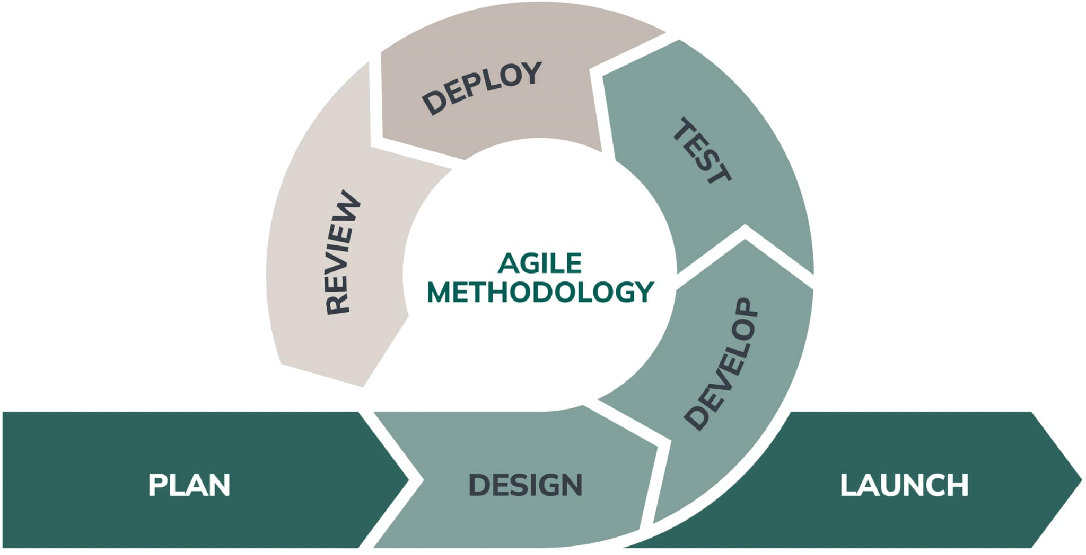

We applied the Agile methodology in developing the system because it allows us to adjust to changes in the project requirements more effectively. This approach ensures our efforts are focused and efficient while also making it easier to improve or modify the system’s design when needed. If there are updates or revisions to the design, Agile helps us track the system’s progress more effectively.

By using Agile, we adopted a flexible and collaborative approach to system development. This method allows us to handle changes smoothly, simplify updates to the system’s structure, and monitor its progress closely. With Agile principles, our goal is to create a reliable, high-quality system that automates and replaces manual processes, improving efficiency and overall service quality for Villa Salud.

**Planning**

In Agile methodology, everything begins with the Planning Phase. Here, we focused on gathering all the information needed to develop the system. We clearly defined the project’s scope and limitations, created an initial plan for implementation, and assessed how feasible and credible the project would be. To better understand what the client needed, we also conducted an interview to gather their requirements and ensure those needs would be implemented effectively in the system.

**Design**

In this phase, we created a layout based on the client’s requirements. We designed the interface to be simple and easy to use, aiming to ensure user satisfaction. To achieve this, we used a minimal color scheme, made the design responsive, and prioritized a user-friendly approach. We used Figma to visualize the system, allowing the client to see a preview of the partial outcome and provide feedback for improvements.

**Develop**

In the development stage, the developer is assigned to work on the system’s integrity, design, layout, and functionality. The developer gathers all the necessary information from the client and ensures the system is properly integrated. The features to be implemented in the system include managing catering reservations, organizing menu packages, automating scheduling, generating reports, creating announcements. When writing the code, the system's design, specs, and the customer's specific requirements are all carefully considered. By taking these aspects carefully, we will make sure that the end product satisfies the system's expectations and is in line with the planned goals.

**Test**

In the testing phase, the Quality Assurance (QA) team checks how well the system works, how it performs, and its overall design. This includes performing functionality, integrity, and unit testing. In addition to testing the system's responsiveness and design, any faults or errors are found and fixed. Before the system is fully implemented at Villa Salud, the researchers will test it with the client, a small group of users, and employees to make sure it is functional.

**Deploy**

After the testing phase, the system will be deployed and checked by the client. During this deployment stage, the client will use the system and test its functionalities and integrations to ensure everything works as expected.

**Review**

The review stage is when the client evaluates their experience using the system and provides feedback. During this stage, the client can also suggest improvements to the system’s functionalities or requirements to enhance its performance.

**Launch**

The launch stage is when the developers officially launch the system and deploy it for public use. During this stage, the system becomes fully operational and accessible to the intended users. The researchers ensure that everything is in place for the system’s smooth functioning, and it is made available for the public or the target audience to begin using.

**3.3.2. Development Tools**

Table 13. Development Tools Used

|  |  |
| --- | --- |
| Programming Languages | JavaScript, PHP |
| Supporting Tools | HTML, CSS, GITHUB |
| Relational Database Management  System | PHP, MySQL |
| Integrated Development Environment | Visual Studio Code, GitHub |
| Server | Google |
| Web Browser | Google Chrome, Microsoft Edge, Safari |

**3.4 TEST METHODOLOGY PROCEDURES**

**3.5 SYSTEM REQUIREMENTS**

**3.6 QUALITY PLAN**

**3.7 EVALUATION PLAN**

**REFERENCES**

* [**https://repository.cpu.edu.ph/handle/20.500.12852/2278?locale-attribute=en**](https://repository.cpu.edu.ph/handle/20.500.12852/2278?locale-attribute=en)**. Bahandian (2017) for Resona Catering Service**
* [**https://www.mdpi.com/2071-1050/14/4/2009**](https://www.mdpi.com/2071-1050/14/4/2009)**. MDPI 2022**
* [**https://www.jetir.org/papers/JETIR2111201.pdf**](https://www.jetir.org/papers/JETIR2111201.pdf)**. JETIR (2021)**
* [**https://eventespresso.com/2024/02/role-of-technology-in-event-management/**](https://eventespresso.com/2024/02/role-of-technology-in-event-management/)**. Verana 2024**
* [**https://www.connectpointz.com/blog/how-manual-processes-hurt-your-business**](https://www.connectpointz.com/blog/how-manual-processes-hurt-your-business)**. How Manual Process Are Hurting Your Business 2022 by Frank Tilleli**
* [**https://whimsical.com/flowcharts**](https://whimsical.com/flowcharts)
* [**https://www.figma.com/**](https://www.figma.com/)
* [**https://www.canva.com/**](https://www.canva.com/)